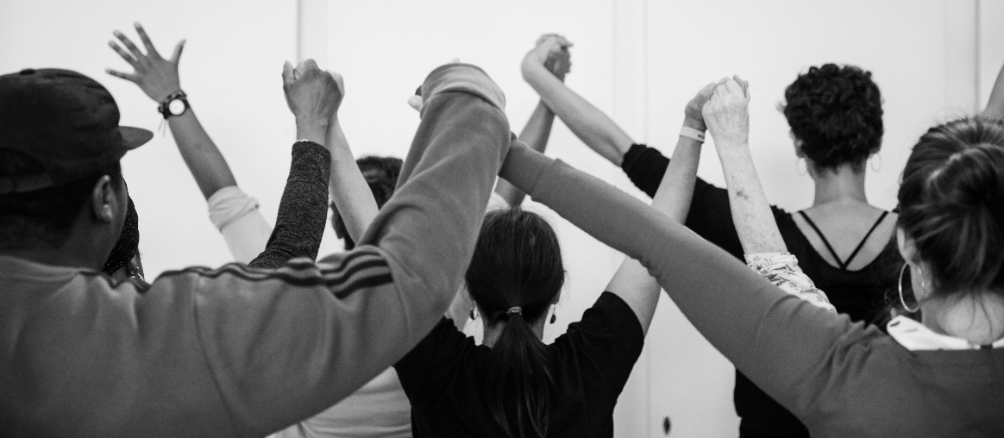
Young Artist Development Programme
This programme is for young women aged 17 – 30 who have experience of, or who are on the fringes of, the Criminal Justice System and want to develop their performance skills and gain an insight into the theatre industry. The programme takes place over nine months focusing on nurturing and supporting new talent and giving a platform to underrepresented female artists to both perform new work and create their own original work.

Criteria
To be eligible for the Young Artist Development Programme, you must be:
- Aged 17 – 30
- Female identifying
- Have experience of the Criminal Justice System, (including arrest, imprisonment, or probation) or be on the fringes of it with drug/alcohol and or mental health needs
- Have previous experience participating in a drama project or equivalent
- Be passionate about acting and interested in pursuing performing as a career
- Ready to commit and be responsible for your own self-development
- Able to attend weekly day time sessions between October 2019 – July 2020 (Please note the core programme will be held on Tuesdays, but there will be additional hours around rehearsal periods)
If you are unsure if any of the above describes you or if you are generally unsure about your suitability for the Young Artist Development Programme, please get in touch and we will be more than happy to speak with you.

The Offer
The Young Artist Development Programme is structured across three seasons taking place over a nine month period. Each season focuses on an essential aspect of performance, gradually building to support participants to create their own work and become equipped for successful careers in the arts.
Structure
Season: | Date: | Activities:
Season One | 1 Oct – 11 Dec 2019 | Developmental master classes, introduction to mentors, audition skills and head shots
Season Two | 13 Jan – 1 April 2020 | Rehearsal and performance of a new play that raises issues of young women and incarceration
Season Three | 27 April – 15 July 2020 | Independent project: Each young artist will have a budget and access to professional artists to realise their own work

Additional benefits:
- Theatre visits
- Access to industry professional mentors
- Book allowance
- 1-1 pastoral support
- Travel fares, lunch and childcare provided
TO APPLY
Please email the completed application form below to: participation@cleanbreak.org.uk by 12:00 pm on Tuesday 10 September
If your application is successful, you will be invited to an audition workshop on 11:00 am – 1:00 pm on Tuesday 17 September.

If you would like any further information on Clean Break’s Young Artist Development Programme please feel free to call us on 020 7482 8600 or email participation@cleanbreak.org.uk
We look forward to hearing from you and good luck!

NOTE FOR REFERRAL PARTNERS:
Please only refer young women who have some experience of theatre or drama, who are interested in pursuing a career in the arts and who are ready to commit to the full schedule of activities as listed above.
YOUNG ARTIST DEVELOPMENT PROGRAMME
APPLICATION FORM

YOUR DETAILS
First name ……………………………………….. Last name……………………………………….
Address ……………………………………….……………………………..………………………...
Post code ……………………………………….. Gender……………………………………...…
Date of Birth …………………………………..… Age……………………………………………
Mobile No. ………………………………………..
Email ……………………………………..…………………………………………………………..

I prefer to be contacted by: Mobile phone __ Email __ WhatsApp __ (Tick as appropriate)
Ethnicity …………………………………………………………………………………………….
Do you consider yourself disabled? ………………………………….
Do you have any access or learning needs that we need to consider? …………………
If yes, please specify……………………

EXPERIENCE
Please give any details of any previous acting or other relevant experience

……………………………………………………………………………………………………………………

……………………………………………………………………………………………………………………

……………………………………………………………………………………………………………………

……………………………………………………………………………………………………………………

What do you hope to gain from this opportunity?

……………………………………………………………………………………………………………………

……………………………………………………………………………………………………………………

……………………………………………………………………………………………………………………

……………………………………………………………………………………………………………………

What challenges might you face in taking part in this programme?

……………………………………………………………………………………………………………………

……………………………………………………………………………………………………………………

……………………………………………………………………………………………………………………

……………………………………………………………………………………………………………………

Please tell us about an actor/ performer who inspires you and why?

……………………………………………………………………………………………………………………

……………………………………………………………………………………………………………………

……………………………………………………………………………………………………………………

……………………………………………………………………………………………………………………

Are you able to fully commit to this programme over 9 months? (please see season dates below) Yes No

Season dates:
- 1st Oct – 11th Dec 2019,
- 13thJan – 1st April 2020
- 27th April – 15th July 2020

Are you able to attend the audition workshop on Tuesday 17 September 2019, 11:00 am – 1:00 pm? Yes No

Declaration
I confirm that I would like to audition for the Young Artist Development Programme.

Signed ……………………………………….… Date ………………………………………………

Please email this completed form to participation@cleanbreak.org.uk or post it to the address below:
Participation / YADP
Clean Break
2 Patshull Road
Kentish Town
London
NW5 2LB

